Tibbo’s hardware modular design and ease of programmability make Tibbo TPB platform ideal for building a device that monitors various sensors, not only environmental parameters but, virtually, any sensor that reports some digital or analog values.

A broad range of Tibbo original sensors supports building a device that monitors any parameters needed and which that can be extended at any time.

Support for multiple protocols, such as ModBus and SNMP, allows seamless device integration into existing infrastructure. Numerous communication ports support all the main sensor types: RS-232, RS-485, Dry Contact, 1-wire, and I2C.

Sensor monitoring device is based on Tibbo TPP3 Gen.2 board, though it is possible to use smaller TPP2 PCB or Gen.1 boards limiting performance or the number of supported features.

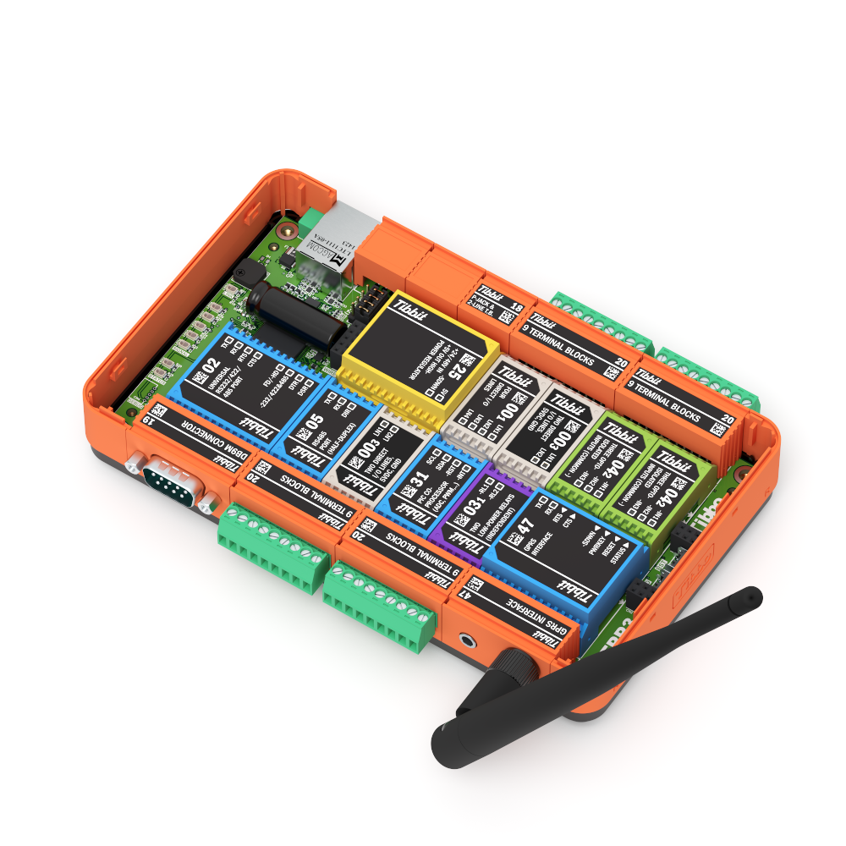

RS-232/RS-485 switchable port,  
DB-9M connector

**Terminal block #1**RS-485, +5VDC, GND

**Terminal block# 2**1-Wire ports, OUT#0, OUT#1, GND

GPRS modem with antenna   
(optional)

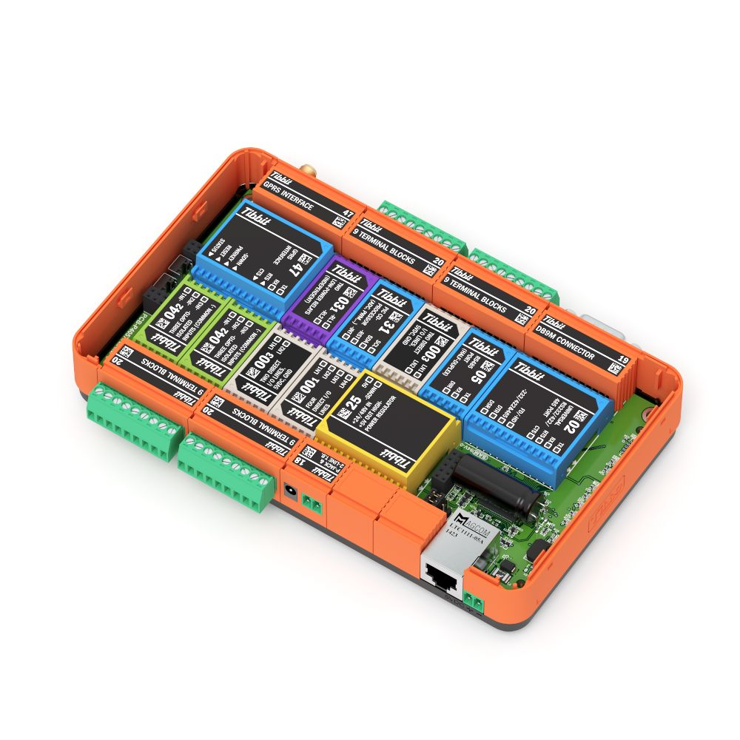

**Terminal block# 3**DC ports, GND

**Terminal block #4**I2C ports, +5VD, GND

System power input  
 12-48VDC

Ethernet  
socket

Direct system power input  
+5VDC

# Technical characteristics

Hardware features

|  |  |
| --- | --- |
| Dimensions (L×W×D, mm) | 176×105×39 |
| CPU | Cortex M3 (32 bits, 120 MHz core speed) |
| RAM | 128 KB |
| Flash | 2 Mb (1 Mb for firmware and 1 Mb for data) |
| EEPROM | 2048 bytes |
| Operating System | TiOS |
| Ethernet port | Embedded 10/100 Base-T with onboard magnetics |
| Wi-Fi | Optional, via GA-1000 expansion card (sold separately) |
| GPRS/SMS | Optional, via tibbit #47 (paid SIM-card required) |
| Additional accessories | DIN-rail mount, vibration protection kit (VPK), 1U shelf for 19” rack mounting |
| Power supply | External, 12/24/48 VDC 500 mA/h. Also, PoE is supported |
| Maximum number of sensors that can be attached to a single device | 64 (with default firmware) |
| Supported communication buses | RS-232*, RS-485, I2C (3 channels), 1-wire** (3 channels) |
| Dry contact ports | 6 |
| Low-power relays | 2 (max 30V, 1A per relay) |
| Multidrop*** support for buses | RS-485, I2C, 1-wire** |

*\*) Usually RS-232 port is used for device management and firmware upload, but it can be switched into RS-485 mode via web-interface thus allowing connection of ModBus or Tibbo original sensors.*

*\*\*) 1-wire ports support so-called “single-wire” protocol (such as implemented in AM2301 humidity and temperature sensor), but, in this case, multidrop feature for the port is disabled, because “single-wire” protocol doesn’t support device addressing.*

*\*\*\*) “Multidrop” means daisy-chain style connection for sensors so that multiple devices can be connected sequentially to a single port. Do not use a star-type connection because of mutual interference.*

*\*\*\*\*) RS-485 port operates in half-duplex mode via single twisted pair. 120 Ohm terminator is required on the open end, especially for long lines.*

Firmware features

* Web interface for device monitoring and configuration
* DHCP protocol support for dynamic network address configuration
* SNMP protocol support, versions v1, and v2c
* Notifications via SMS messages or SMTP (Tibbit #47 GPRS modem with installed paid SIM-card is required for sending SMS messages)
* Export for sensor values as XML or JSON file
* Out-of-the-box AggreGate™ support
* ModBus and ModBus RTU support over serial lines or TCP/IP
* Access control lists for IP-based access
* Support for Green (good), Yellow (pre-alert) and Red (alert) zones for sensor values with selectable actions for those zones
* Flexible configuration for custom hardware layouts

Dimensions

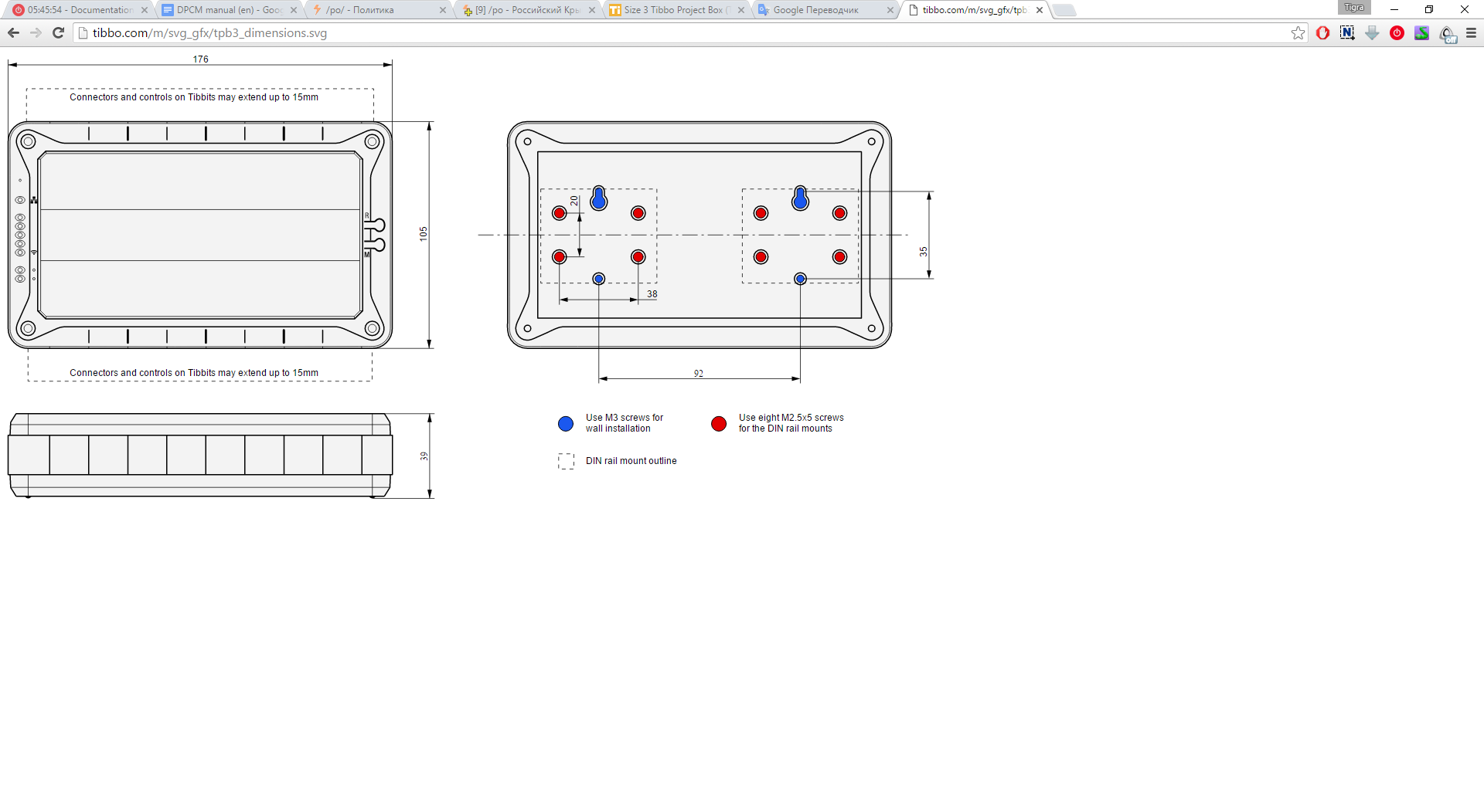

Standard device hardware layout

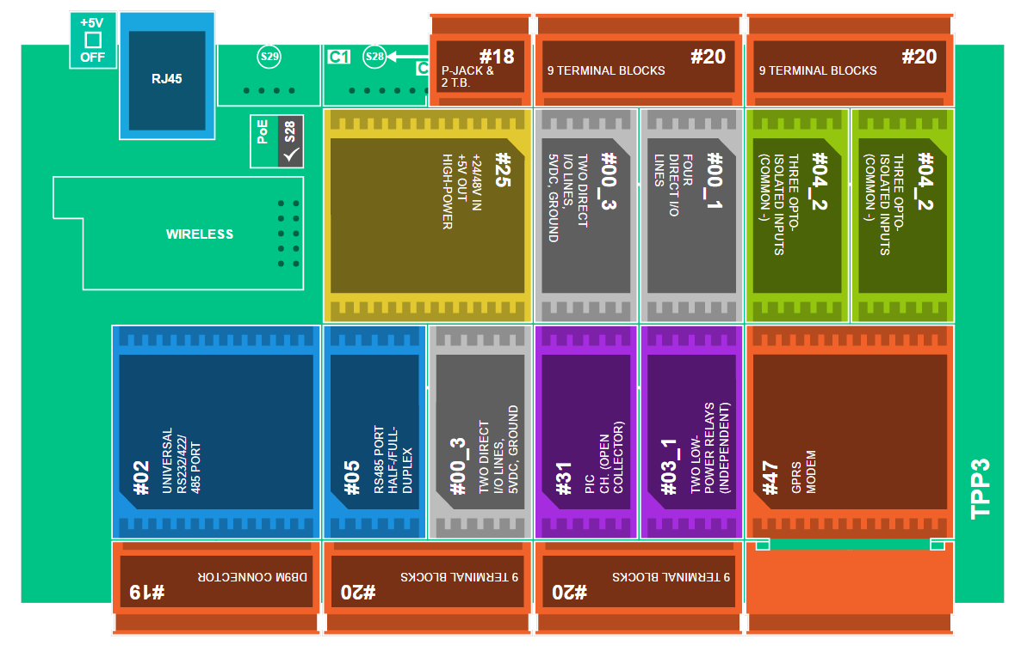

*Tibbit layout on PCB*

|  |  |  |
| --- | --- | --- |
| 1 | Tibbit #02 (M1S): RS232/422/485 port | 1 |
| 2 | Tibbit #05 (M1S): RS485 port | 1 |
| 3 | Tibbit #00-3 (M1S): Two direct I/O lines, +5V power, ground | 2 |
| 4 | Tibbit #31 (C1): PIC coprocessor with 1-Wire firmware uploaded | 1 |
| 5 | Tibbit #03-1 (M1S): Two low-power relays (configuration 1) | 1 |
| 6 | Tibbit #47 (H2): GPRS modem | 1 |
| 7 | Tibbit #04-2 (M1S): Three isolated inputs, common (-) | 2 |
| 8 | Tibbit #00-1 (M1S): Four direct I/O lines | 1 |
| 9 | Tibbit #25 (M2T): High-power 5V supply, 12/24/48V input | 1 |
| 10 | Tibbit #19 (C2): DB9M connector | 1 |
| 11 | Tibbit #20 (C2): Nine terminal blocks | 4 |
| 12 | Tibbit #18 (C1): Power input | 1 |
| 13 | Size 3 Tibbo Project PCB, Gen. 2 | 1 |

# 